Time | Area of curriculum | Suggested links  We will update these resources to provide different learning challenges over time. Many of these links provide on-going provision. Choose an activity from each box every day. Please be aware that as schools begin to reopen, some sites may resume subscription based services.
9:00-9:30 | Exercise Time  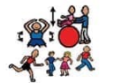 | - Exercises in the garden if available  P.E with Joe  https://www.nhs.uk/10-minute-shake-up/shake-ups  https://www.cambslearntogether.co.uk/services-to-schools/pe/pe-at-home  - Aerobics/yoga https://www.youtube.com/user/CosmicKidsYoga
9:40-10:00 | Phonics  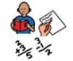 | Letters and Sounds: for home and school - online phonics lessons that follow phases 2 to 5 of the Letters and Sounds programme.  https://www.phonicsplay.co.uk/  teachyourmonstertoread.com  https://monsterphonics.com/  https://www.ruthmiskin.com/  - Read Write Inc. videos  Choose 5 more words from the first 100 High Frequency words to learn this week. Remember as an extra challenge, could you include that word in the context of a spoken / written sentence and record these on tapestry.
10:15-10:30 | Writing | This week we are thinking about writing instructions  - When do we use instructions? Can you find any examples of instructions around your home?  - My instructions are muddled; can you help me put my instructions in the right order?  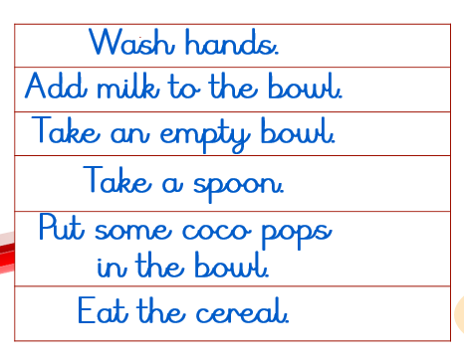  - Can you practise giving and receiving instructions? Using Duplo, lego. Pens / paint and paper, building blocks or anything you have at home, could you carry out an instruction and see if your adult can copy- e.g. “put red lego piece on top of the blue lego piece and push together.” Can you follow your adult’s instructions? Talk about what sort of information you needed to share- colour, action (bossy verb), position of the block etc.  - Can you write your own sentence / set of instructions for staying safe in the sun? Here are some pictures to help.  If you want some additional links and resources for other writing challenges, then try some of these sites below:  https://readingeggs.co.uk/ -. It is free for 30 days. Can support with English and maths.  - Pobble  - Indoor and Outdoor English Challenges  - Once Upon a Picture
11:00-11:20 | Maths | This week our Maths lessons will be based around Oliver’s Vegetables 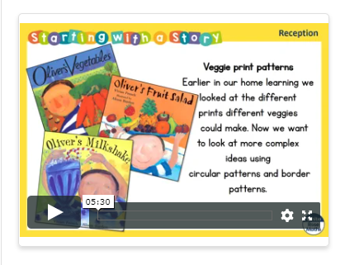  W/C 29..6.20 https://whiterosemaths.com/homelearning/early-years/  If you want some further ideas:  Talk about positional language whilst a child is playing and talk about shapes around the house. Measure objects with string, using feet, hand spans and digits. Talk about how tall things are and measure the height of different members of the family.  Counting, sharing, one more and one less, doubling, counting in twos and fives and tens. Keep it practical using objects from around the house and toys. Creating a shop can be a fun way to practise using money and counting.  (Guidance for parents and Carers) https://whiterosemaths.com/homelearning/  https://www.topmarks.co.uk/maths-games
111:20-1:00 | Lunch | Use this time to relax and refuel. Could you help your adult prepare lunch perhaps? Could you help design a healthy lunch plate?  Understanding of the World (10 minutes):  - Talk about the weather (go out in the garden, balcony or street if possible, even when it is raining)  - Close your eyes and ask your child what he/she can hear/smell  - What can you see?  Talk about the day of the week and date. Ask your child find the number or write the date. Sing the days of the week song.  Physical Session 2 (30 minutes):  - Go out for a walk/cycle/on a scooter/exercise in your garden
1:00-1:30 | Reading | Snuggle up and share a favourite picture book together. Talk about the front cover and ask your child to tell you what the story is about. Talk about the pictures. Talk about the characters. Talk about where the characters are.  - bbc.co.uk/cbeebies/grownups/cbeebies-storytime-app  This story could provide a focus for the day / afternoon – act out the story, draw a picture, draw a story map, make a zigzag book to write the story in words and pictures. (This could form your writing task for the day)  https://www.lovereading4kids.co.uk/  https://stories.audible.com/start-listen  http://www.childrenslibrary.org/
1:30– 1:50 | Understanding of the World, Expressive Arts and Design | This might include: cooking, playing with water, digging in the mud, playing with sand, arts and crafts, cooking, building models, making patterns with natural materials, den building, home corner or shop role play, singing nursery rhymes and songs, playing musical instruments. Many of these will provide an opportunity for your child to explore on their own.  The times are a guide only – some days your child will not be able to concentrate for long -but try to build up to these times to support your child for when they return to school.  Intersperse the structured learning with breaks.  Give your child time to explore learning on their own e.g. playing with a bowl or bucket of water, digging in the mud.  Make the most of daily/weekly events at home as these are fun and provide a great opportunity to talk and extend your child’s learning:  hungrylittleminds.campaign.gov.uk  Weekly project available now on Tapestry  Weekly picture news:  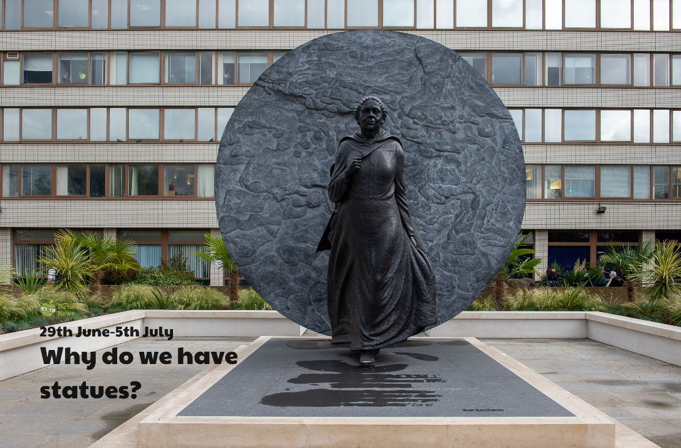  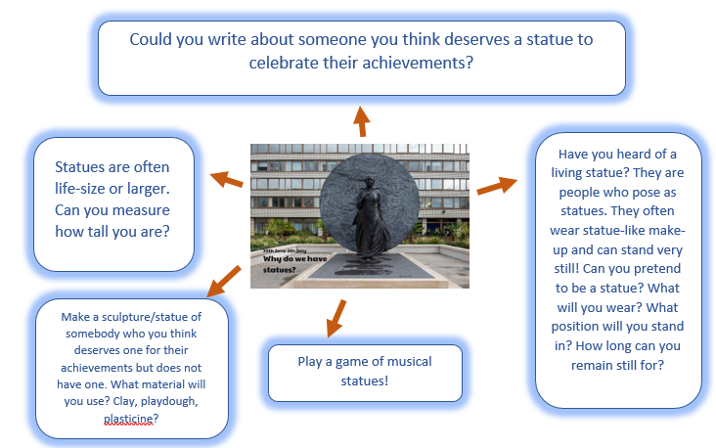
2:00-3:00 | Reading and Quiet time | - Reading (10 minutes):  Read a book together encouraging your child to talk about the pictures, read words that they know and use their phonics to sound out some of the words. (This is different to the session above in that the child should take more of a lead).  https://home.oxfordowl.co.uk/  Play a game together (10 minutes):  A good opportunity to practise taking turns and sharing (jigsaws, Board games)  https://parentingfromtheheartblog.com/  - bbc.co.uk/cbeebies/watch/playtime-island-games-new  www.scholistic.com  - Card games  - Lego challenges  https://www.cambslearntogether.co.uk/asset-library/CCC-Home-Learning-Parents-Guide.pdf

