Year 6 29.6.20

Time | Area of curriculum | Suggested links  We will update these resources to provide different learning activities.  Choose an activity from each box, each day. Many of the resources are  designed to provide on-going provision  Please be aware as schools reopen, some sites may resume their subscription  services.
9:00-10:00 | Exercise Time  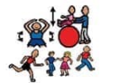 | - Exercises in the garden if available  - P.E with Joe  https://www.nhs.uk/10-minute-shake-up/shake-ups  https://www.cambslearntogether.co.uk/services-to-schools/pe/pe-at-home
10:00-11:00 | Maths  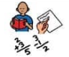 | https://whiterosemaths.com/homelearning/year-6/  - Summer term- week 10- 29th June You can find follow up activities linked to the tutorial videos here:  https://www.bbc.co.uk/bitesize/tags/zncsscw/year-6-and-p7-lessons  Monday- LC: To introduce ratio  Tuesday- LC: To calculate ratio  Wednesday LC: To use scale factors  Thursday LC: To problem solve  Friday: To consolidate my learning  If you want any further resources check out some of the sites below:  https://www.themathsfactor.com - Created by Carol Vordeman. Has a great reputation, monitors and explains maths functions and is free until the end of this school term, though parents / Carers will need to register.  - Gareth Metcalfe daily lessons  - Indoor and Outdoor Challenges  - Problem solving activities and games from Nrich  - Maths trail at home  - Subject resources  https://www.learningresources.co.uk/  http://www.primaryhomeworkhelp.co.uk/  https://login.mathletics.com/  https://www.mangahigh.com/en-gb/  Make sure that you practise your multiplication tables- use this link https://www.timestables.co.uk/ to practise a different times table each week!
11:00-12:00 | English | This week our focus is on instructional writing.  - Mind map when you use / need instructions. Can you explain why instructions are important?  - Can you explain the importance of the following features of instructional writing?  - 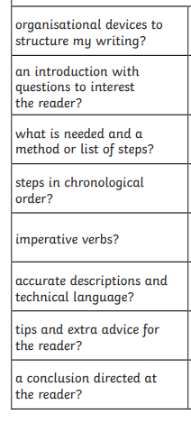  - 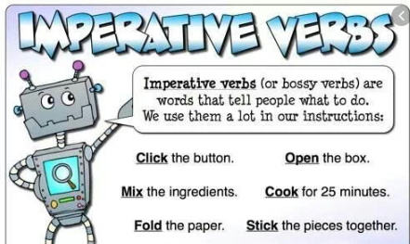 can you think of 5 imperative verbs you might see in instructional writing for- washing a car, baking a cake, at school, before bed.  - Could you design your own structure either with lego, building blocks, junk modelling or if you don’t have access to those resources at home you could draw / paint your idea. It could be a home, a youth club, a park a zoo, a water park etc  - Can you write up your instructions using all the features above so that someone else could come along and build the exact same structure you designed?  - Evaluation- how successful were your instructions? What went well? What could have been even better and why?  If you want any further resources, check out some of the links below  - BBC Bitesize daily lessons  - English Challenges  - Pobble  Remember to keep learning spellings from the year 6 spelling list this half term. As an extra challenge, could you put these words in to the context of a complex sentence?
12:00-1:00 | Lunch | Use this time to relax and refuel. Could you help your adult prepare lunch perhaps?
100-1:30 | Reading | AR books if at home  https://www.childrenslibrary.org/  https://home.oxfordowl.co.uk/ this is a great website that you can access books to read electronically for free!
1:30–2:30 | Topic | - weekly project activity on seesaw  - weekly picture news activity on seesaw  The Garden Project  - Study topics  - BBC Bitesize daily lessons  The following STEM activity is totally optional and must only be carried out with the consent of your adult at home!  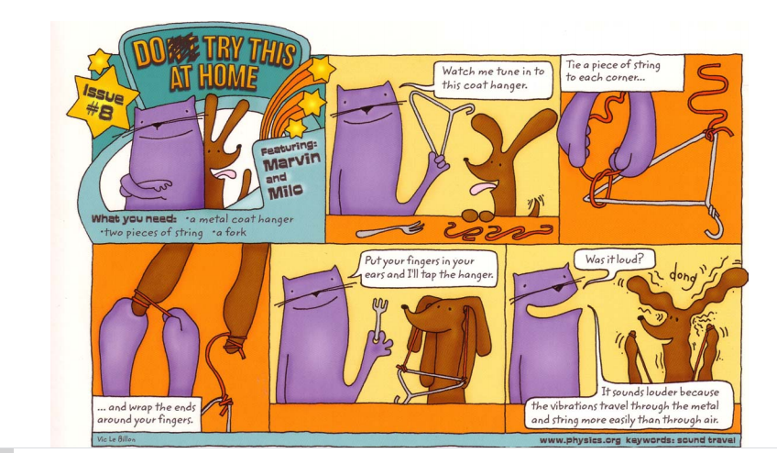  You could also check out this link: https://lifestyle.howstuffworks.com/crafts/science-projects/science-projects-for-kids-states-of-matter.htm for more easily explained science experiments. Always ask permission at home before conducting any experiments / using equipment and resources.
2:30-3:00 | Screen and Quiet time | Outdoor art activities  - Drawing, painting, junk modelling  - Baking  - Jigsaws  - Listening to/making music  - Card games  - Board games  - Online maths games  - Lego challenges  https://login.mathletics.com/  https://www.mangahigh.com/en-gb/

