Time | Area of curriculum | Suggested links  We will update these resources to provide different learning challenges over time. Many of these links provide on-going provision. Choose an activity from each box every day. Please be aware that as schools begin to reopen, some sites may resume subscription based services.
9:00-9:30 | Exercise Time | - Exercises in the garden if available  - P.E with Joe  -https://www.nhs.uk/10-minute-shake-up/shake-ups  - Aerobics/yoga- https://www.youtube.com/user/CosmicKidsYoga
9:30-9:50 | Phonics  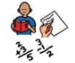 | Letters and Sounds: for home and school - online phonics lessons that follow phases 2 to 5 of the Letters and Sounds programme.  https://www.phonicsplay.co.uk/  https://monsterphonics.com/  https://www.ruthmiskin.com/  - Attached to this timetable are the Year 1 and 2 common exception words. Pick another 10 words to learn this week. Can you write them as part of a sentence?
10:05-11:00 | English | This week we are going to focus on instructions  - Mind map when we see / use / need instructions.  - Spot the features of instructions in the text below (How To Make Pumpkin Soup). Can you find examples of: title and subheadings, equipment, method (step by step instructions), bossy verbs, numbered instructions, photographs/ pictures?  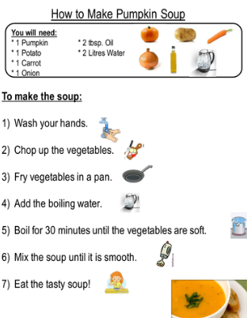  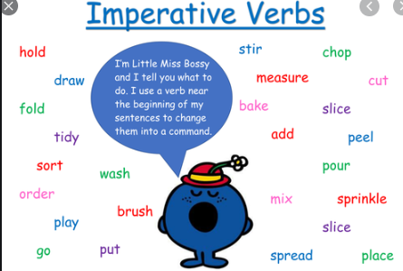 top tip: Remember bossy or imperative verbs give an instruction.  - Can you put the bossy verbs into the sentences?  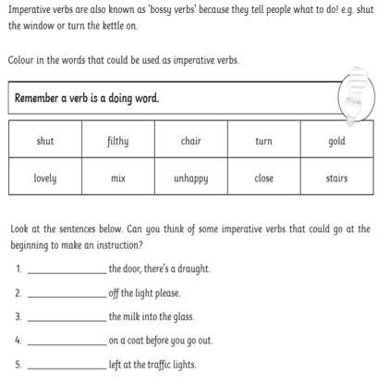  - My instructions are muddled, can you help me put my instructions in the right order?  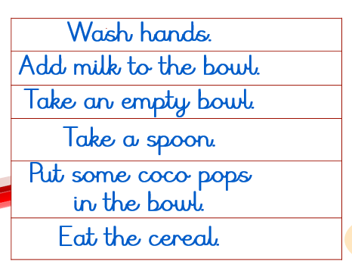  - Can you write your own set of instructions for staying safe in the sun?  - If you want some additional links and resources then try some of these sites below:  https://readingeggs.co.uk/ -. It is free for 30 days. Can support with English and maths.  BBC Bitesize daily lessons  https://classroomsecrets.co.uk/free-home-learning-packs/  Pobble  Indoor and Outdoor English Challenges  Once Upon a Picture
11:00-12:00 | Maths | (Guidance for parents and Carers) https://whiterosemaths.com/homelearning/  Summer term- week 10- w/c 29th June  This link will take you to your daily Maths tutorial videos.  https://whiterosemaths.com/homelearning/year-1  There are follow up activities linked to the tutorial videos: https://www.bbc.co.uk/bitesize/tags/zjpqqp3/year-1-and-p2-lessons  Monday- ordering numbers  Tuesday- recognising coins  Wednesday – recognising notes  Thursday – recognising coins  Friday- consolidating learning – weekly maths challenge.  If you want some extra challenges this week in maths you could visit these sites…  https://www.themathsfactor.com - Created by Carol Vordeman. Monitors and explains maths functions and is free until the end of this school term, though parents will need to register.  https://whiterosemaths.com/resources/classroomresources/problems/page/3/  https://www.topmarks.co.uk/maths-games  Practise the multiplication tables you are not sure of each week using this link to help you: https://www.timestables.co.uk/
12:00-1:00 | Lunch | Use this time to relax and refuel. Could you help your adult prepare lunch perhaps? Could you help set the table for lunch / dinner?
1:00-1:30 | Reading | Use this time to read and be read to. Here are some links below that might be helpful.  https://www.lovereading4kids.co.uk/  https://stories.audible.com/start-listen  https://home.oxfordowl.co.uk/
1:30– 2:30 | Topic | Weekly project activity on seesaw  Weekly picture news activity on seesaw  https://www.stem.org.uk/resources/elibrary/resource/32005/listening-sounds this week there is a video to watch on sounds with a quiz at the end.  - The Garden Project  - Subject resources  - BBC Bitesize daily lessons
2:30-3:30 | Quiet /screen time | - Drawing, painting, junk modelling, play dough  - Baking  - Jigsaws  - Listening to/making music  - Board games  - Outdoor art activities  - Card games  - Online maths games  - Lego challenges  This website below offers some additional complementary ideas for indoor and outdoor learning activities:  https://www.cambslearntogether.co.uk/asset-library/CCC-Home-Learning-Parents-Guide.pdf

