Time | Area of curriculum | Suggested links  We will update these resources to provide different learning challenges over time. Choose an activity from each box every day.
9:00-9:30 | Exercise Time  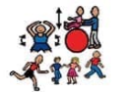 | - Exercises in the garden if available  - Aerobics/yoga  https://www.youtube.com/user/CosmicKidsYoga  https://www.nhs.uk/10-minute-shake-up/shake-ups  https://www.cambslearntogether.co.uk/services-to-schools/pe/pe-at-home
9:40-10:00 | Phonics  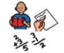 | Letters and Sounds: for home and school - online phonics lessons that follow phases 2 to 5 of the Letters and Sounds programme.  teachyourmonstertoread.com  https://monsterphonics.com/  https://www.ruthmiskin.com/  - Read Write Inc. videos  - An ideal place to start will be  - Tricky Words  - Phonics – Sounds  - Sentence Starters  Choose 5 more words from the first 100 High Frequency words to learn this week. Remember as an extra challenge, could you include that word in the context of a spoken / written sentence and record these on tapestry.
10:15-10:30 | Writing | Have a daily theme or story that you base this on or keep a diary of what you see each day on your walk. This can be a list or simple sentences such as I saw --- or I liked--- with a picture.  - Pobble  - Indoor and Outdoor English Challenges  - Once Upon a Picture  Could you use the pirate storyboard to write your own story this week?  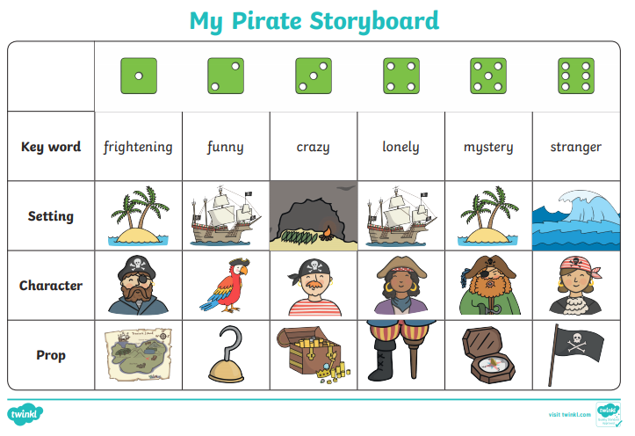
11:00-11:20 | Maths | Talk about positional language whilst a child is playing and talk about shapes around the house. Measure objects with string, using feet, hand spans and digits. Talk about how tall things are and measure the height of different members of the family.  Counting, sharing, one more and one less, doubling, counting in twos and fives and tens. Keep it practical using objects from around the house and toys. Creating a shop can be a fun way to practise using money and counting.  (Guidance for parents and Carers) https://whiterosemaths.com/homelearning/  will find daily lessons for your child here:  https://whiterosemaths.com/homelearning/early-years  https://www.topmarks.co.uk/maths-games
111:20-1:00 | Lunch | Use this time to relax and refuel. Could you help your adult prepare lunch perhaps? Could you help design a healthy lunch plate?  Understanding of the World (10 minutes):  - Talk about the weather (go out in the garden, balcony or street if possible, even when it is raining)  - Close your eyes and ask your child what he/she can hear/smell  - What can you see?  Talk about the day of the week and date. Ask your child find the number or write the date. Sing the days of the week song.  Physical Session 2 (30 minutes):  - Go out for a walk/cycle/on a scooter/exercise in your garden
1:00-1:30 | Reading | Snuggle up and share a favourite picture book together. Talk about the front cover and ask your child to tell you what the story is about. Talk about the pictures. Talk about the characters. Talk about where the characters are.  - bbc.co.uk/cbeebies/grownups/cbeebies-storytime-app  This story could provide a focus for the day / afternoon – act out the story, draw a picture, draw a story map, make a zigzag book to write the story in words and pictures. (This could form your writing task for the day)  https://www.lovereading4kids.co.uk/  https://stories.audible.com/start-listen  http://www.childrenslibrary.org/
1:30– 1:50 | Understanding of the World, Expressive Arts and Design | This might include: cooking, playing with water, digging in the mud, playing with sand, arts and crafts, cooking, building models, making patterns with natural materials, den building, home corner or shop role play, singing nursery rhymes and songs, playing musical instruments. Many of these will provide an opportunity for your child to explore on their own.  The times are a guide only – some days your child will not be able to concentrate for long -but try to build up to these times to support your child for when they return to school.  Intersperse the structured learning with breaks.  Give your child time to explore learning on their own e.g. playing with a bowl or bucket of water, digging in the mud.  Make the most of daily/weekly events at home as these are fun and provide a great opportunity to talk and extend your child’s learning:  - When the Bin Men visit - watch together and talk about what is happening and talk about what happens to the rubbish. Talk about recycling and ask your child to sort what needs to be recycled. Your child could be responsible for putting the recycling in the recycle bin. Talk about when the bin is empty, half full and full or even overflowing;  Ask your child to write a list of what goes in the recycling bin – This could be stuck to the bin.  NB: Wash hands after touching rubbish and bins  - Washing clothes– ask your child to help sort the laundry for washing; peg out the clothes together – your child can sort the socks into pairs (talk about the patterns and colours and do some counting in 2s)  - hungrylittleminds.campaign.gov.uk
2:00-3:00 | Reading and Quiet time | - Reading (10 minutes):  Read a book together encouraging your child to talk about the pictures, read words that they know and use their phonics to sound out some of the words. (This is different to the session above in that the child should take more of a lead).  https://home.oxfordowl.co.uk/  Play a game together (10 minutes):  A good opportunity to practise taking turns and sharing (jigsaws, Board games)  https://parentingfromtheheartblog.com/  - bbc.co.uk/cbeebies/watch/playtime-island-games-new  www.scholistic.com  - Card games  - Lego challenges  https://www.cambslearntogether.co.uk/asset-library/CCC-Home-Learning-Parents-Guide.pdf

